✅ Task 3: REST - Get Country Based on Country Code
Scenario:
This task involves creating a RESTful web service using Spring Boot that returns a specific country’s details when the country code is passed in the URL. The country data is fetched from the XML configuration file (country.xml). The matching is done case-insensitively using the @PathVariable annotation. This eliminates the need for a separate service layer.

Controller Code (CountryController.java):
package com.cognizant.spring_learn.controller;

import com.cognizant.spring_learn.Country;
import org.slf4j.Logger;
import org.slf4j.LoggerFactory;
import org.springframework.context.ApplicationContext;
import org.springframework.context.support.ClassPathXmlApplicationContext;
import org.springframework.web.bind.annotation.*;

import java.util.List;

@RestController
public class CountryController {

private static final Logger LOGGER = LoggerFactory.getLogger(CountryController.class);

@GetMapping("/country/{code}")
public Country getCountry(@PathVariable String code) {
LOGGER.info("START - getCountry with code: {}", code);

ApplicationContext context = new ClassPathXmlApplicationContext("country.xml");
List<Country> countryList = (List<Country>) context.getBean("countryList");

Country result = countryList.stream()
.filter(country -> country.getCode().equalsIgnoreCase(code))
.findFirst()
.orElse(null);

LOGGER.info("Country Found: {}", result);
LOGGER.info("END - getCountry");

return result;
}
}

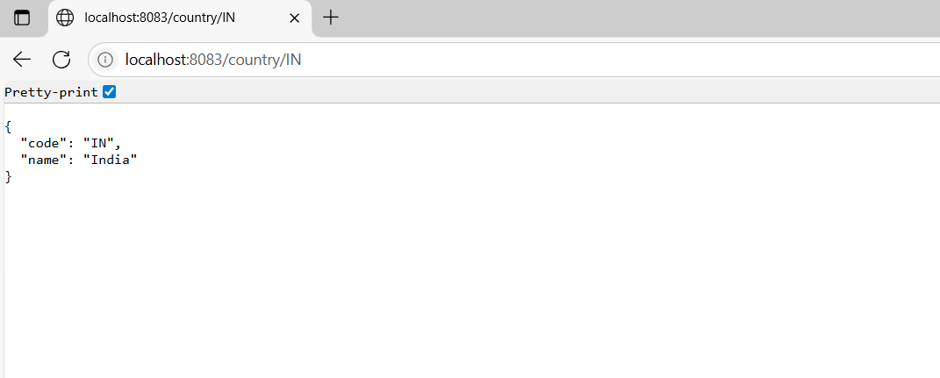

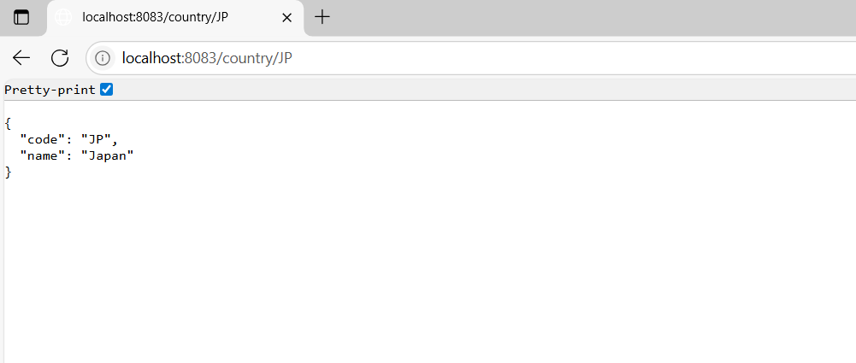

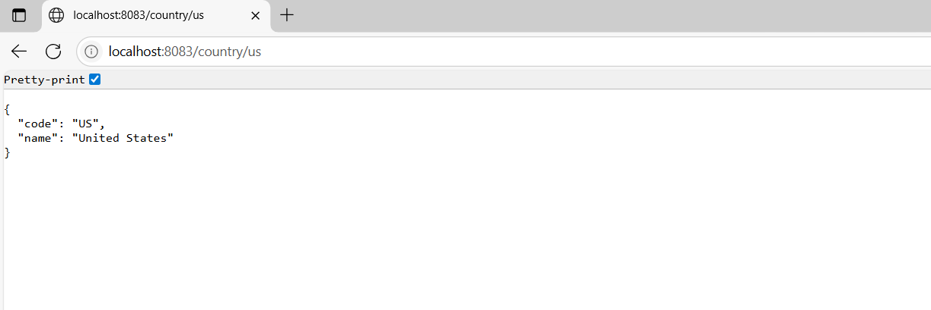

📸 Screenshot: Console Logs
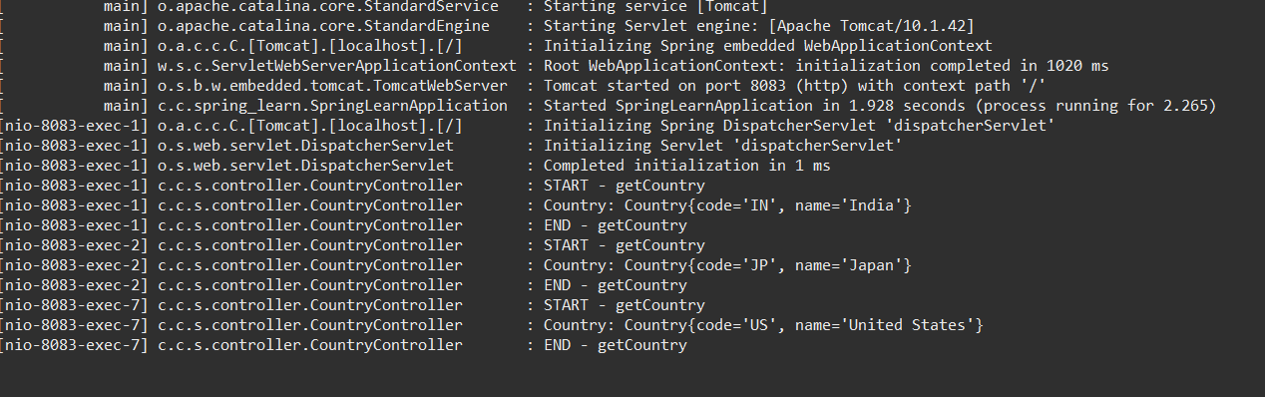
Complete Screenshot :
